Web Development – Mr. Turner

Project – Picture Puzzle

**Project Overview**

Everyone likes doing a puzzle. Your page will allow users to mix up the pieces of a spiderman puzzle and then click them back into place.

**Display**

The list below includes the essential elements of the page.

* Take any image and break it up into 16 identical rectangles. You will need to use a program like photoshop or paint to do this or you can use the spiderman puzzle provided.
* Add a *Click to Shuffle* button.

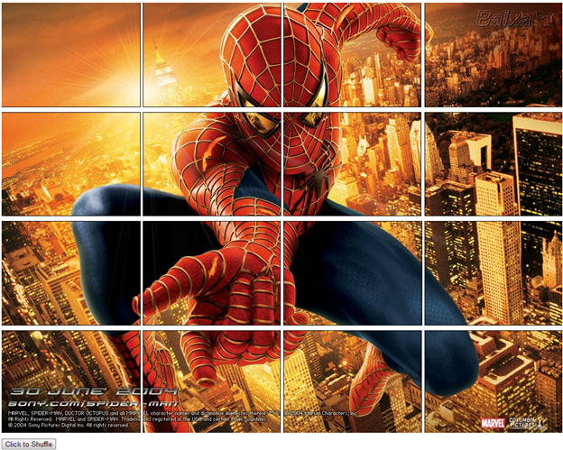

**Functionality**

When the page loads, the puzzle should be solved so that the user can have a look it.

When the user clicks the shuffle button, move the pieces into random positions.

The puzzle operates on a click interface. When the user clicks on the first puzzle piece, that piece is considered selected. A selected piece should have some visual clue that it has been selected. You can use a border or opacity to make it look different from the others.

When the clicks on the second puzzle piece, it should switch places with the selected puzzle piece. Afterwards there should be no selected piece and the display should return to normal.

The user continues switching pieces until the puzzle is solved. When all of the pieces are in their original positions, the page should alert a congratulatory message.

**Enhancements**

* Create a homepage for your site. The homepage will give the user the option of choosing from several different puzzles. Each of these options can link to a different page with a different puzzle. Many of the Javascript functions and all of the CSS can be stored in common files.

**Programming Skills**

* Comprehension of the specifications sheet.
* Manipulating back end information and representing it properly in the display.
* Using HTML and CSS to create a pleasant and intuitive display.